# Overview of Da Vinci PDex Drug Formulary

The Da Vinci PDex Drug Formulary provides the mechanics for searching and managing lists of brand-name and generic prescription drugs that a health insurer agrees to pay for (partially or completely) as part of health insurance coverage. The primary use cases for this guide are aimed at allowing patients to understand the costs and alternatives for drugs that have been prescribed and compare them across different insurance plans.

There are two FHIR® profiles introduced below.

1. **CoveragePlan -** a Resource that provides links to information about the plan and formulary, contact information, descriptions of DrugTiers with their associated cost sharing models, and a list of FormularyDrugs*.*
2. **FormularyDrug –** aprofile of the FHIR R4 MedicationKnowledge Resource that provides plan-specific information about prescription drugs. Cost sharing information for the drug is described by reference to a drug tier that is defined as part of a coverage plan. Extensions to the MedicationKnowledge Resource support search use cases. A typical Formulary Structure is pictured below.

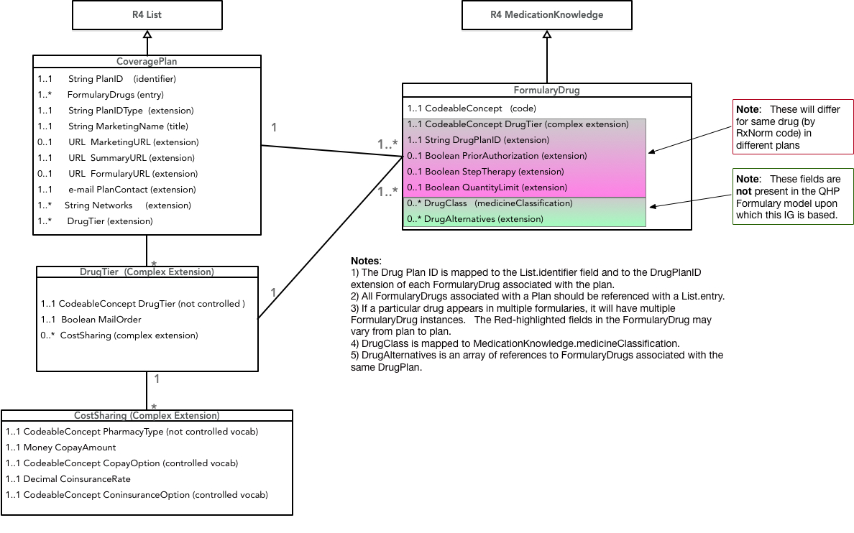

Source - <http://hl7.org/fhir/us/Davinci-drug-formulary/>

# Document Conventions

## Identifier vs id :

An **identifier** denotes variables whereas an **id** denotes resources.

## Searching in the Raw Message

Information can be found in two ways :

* By scrolling through the results.
* By using **CTRL + F** to use your search box to type in a portion of a keyword relevant to your search.

## Filtering results with the Report Body Bundle

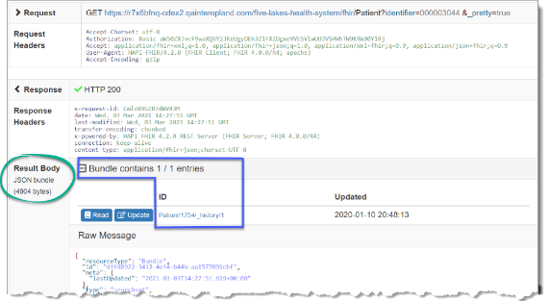The **Result Body** section contains a line at the top that reads **Bundle** contains **1 / 1** entries. This line shows how many results matched the query that was specified.

The first number is the count of results included in this response, the second is the total number of records satisfying that query in this PIT.

When a query matches many records, the numbers can be different because the FHIR server has a limit on the number of records it can return in a single response.

## Search Parameters Add Tool

Click Add ( [](https://us-prod.asyncgw.teams.microsoft.com/v1/objects/0-eus-d13-92fe3deb1ab2c9b690436b7ed8a5fd54/views/imgo)) in Search Parameters when you need to add a search parameter.

Contents

Overview of Da Vinci PDex Drug Formulary 1

Document Conventions 2

Identifier vs id : 2

Searching in the Raw Message 2

Filtering results with the Report Body Bundle 2

Search Parameters Add Tool 2

Scenario 1 - Estimate a Medication’s Cost Under a Current Health Plan 1

Problem Statement 1

Problem Solution 1

Stakeholder Participation 1

Query 1: Find the Patient id Using the Patient Resource in the Specialist Network Administration PIT 2

Query 2: Find a Patient’s Medications Using the MedicationRequest Resource in the Specialist Network Administration PIT 6

Query 3: Find the rxnorm code Using the Medication Resource in the Specialist Network Administration PIT 8

Query 4: Find the Patient id Using the Patient Resource in the Better Health Insurance Payer PIT. 10

Query 5: Find the Patient’s Current Coverage Plan Using the Coverage Resource in the Better Health Insurance Payer PIT 12

Query 6: Find Formulary Coverage Plan id Using the InsurancePlan Resource in the MiHIN PIT 15

Query 7: Determine the Drug’s Tier Using the Formulary Coverage Plan id and MedicationKnowledge Resource in the MiHIN PIT 18

Query 8: Find the Associated Copay for the Medication Tier Using the List Resource in the MiHIN PIT 20

# Scenario 1 - Estimate a Medication’s Cost Under a Current Health Plan

## Problem Statement

Curtis Santos has been given a new prescription for Azithromycin by his doctor. How can he determine the co-pay amount for the medication on his current insurance plan?

## Problem Solution

**Action:** Explore ways to showcase how to retrieve the patient information then cross reference the medication information with a patient’s insurance plan.

**Precondition:** Use the queries listed below to search the Specialist Network Administration, Soldier Health Alliance, and Better Health Insurance PITs to locate a Patient id, Medication id, patient coverage, drug tier, and co-pay amount.

**Success Criteria:** Successfully locate the patient’s co-pay amount for his current insurance.

## Stakeholder Participation

Queries you will complete:

1. Find the Patient id Using the Patient Resource in the Specialist Network Administration PIT.
2. Find a Patient’s Medications Using the MedicationRequest Resource in the Specialist Network Administration PIT.
3. Find the rxnorm code Using the Medication Resource in the Specialist Network Administration PIT.
4. Find the Patient id Using the Patient Resource in the Better Health Insurance Payer PIT.
5. Find the Patient’s Current Coverage Plan Using the Coverage Resource in the Better Health Insurance Payer PIT.
6. Find a Corresponding Coverage Plan id using the MedicationKnowledge Resource in the Better Health Insurance Payer PIT.
7. Find Formulary Coverage Plan id Using the InsurancePlan Resource in the MiHIN PIT.
8. Determine the Drug’s Tier Using the Formulary Coverage Plan id and MedicationKnowledge Resource in the MiHIN PIT.
9. Find the Associated Copay for the Medication Tier Using the List Resource in the MiHIN PIT.

### Query 1: Find the Patient id Using the Patient Resource in the Specialist Network Administration PIT

In this query, begin by navigating to the Sandbox Dashboard and clicking on the **Specialist Network Administration**PIT.

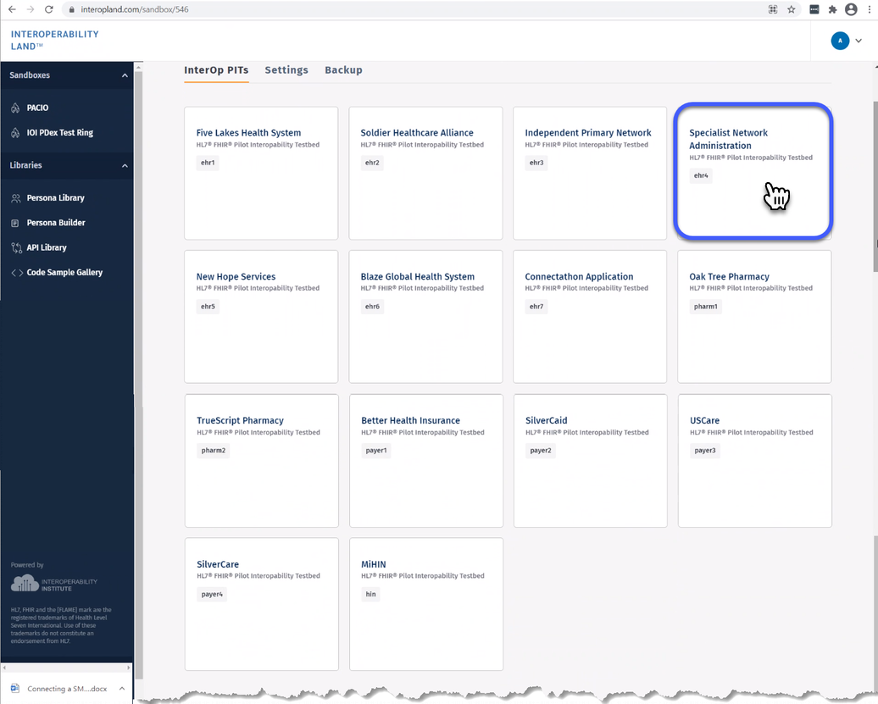

1. Navigate to your **Search** tab in the **Specialist Network Administration** PIT and choose **Patient** from the Resources navigation menu. Now use the **Search** **Parameters** tool find the Patient id record for Curtis.
2. There are several ways to search for a patient record. In this example, using your **Search Parameters** dropdown menu, choose **family – A portion of the family name of the patient**, verify your search is **Matches**, and then type the patient **family** name **Santos** in the corresponding box.
3. Click **Add** () to add a search parameter.
4. Then use your **Search Parameters** dropdown menu to choose **given – A portion of the given name of the patient**, verify your search limit is **Matches**, then type the patient **given** name **Curtis** in the corresponding box.
5. Click **Search** () to display the **Patient** **id** records associated with **Curtis Santos**.

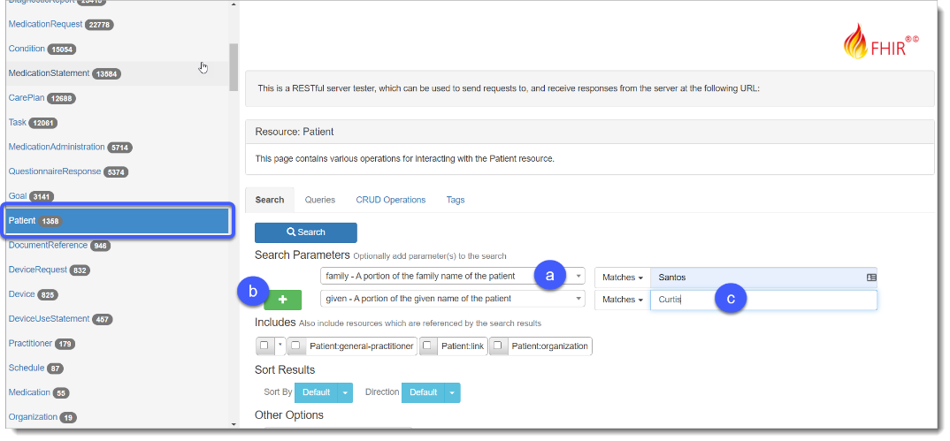

1. Click **Read** or scroll down to view the record detail for Curtis.

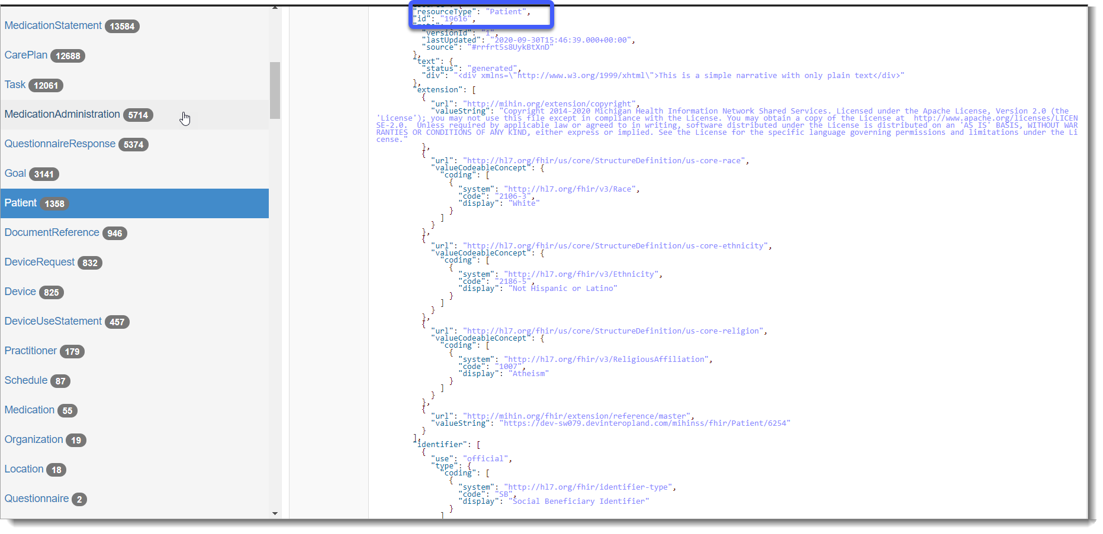***Tip:*** *Make a note of the* ***patient id*** *for Curtis**for future queries.*

### Query 2: Find a Patient’s Medications Using the MedicationRequest Resource in the Specialist Network Administration PIT

Curtis has been prescribed a new medication, but you will need to know an identifier for that medication to see what tier it is in the Drug Formulary.

1. Navigate to the **Search** tab in the **Specialist Network Administration** PIT and choose **MedicationRequest** from your left Resources navigation menu. Now you can use your **Search** **Parameters** tool find the Patient **id** record for Curtis.
2. Using your **Search Parameters** arrow, choose **patient – Returns prescriptions for a specific patient**, verify your search is **Matches**, and
3. 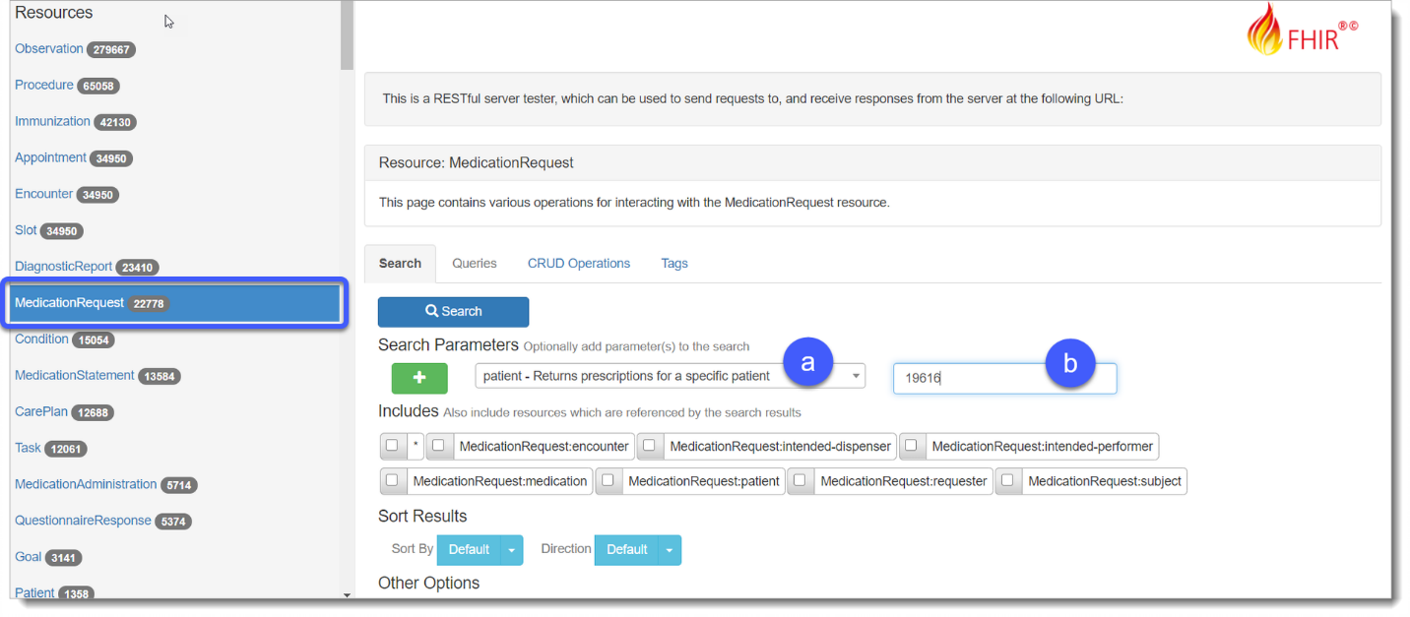Type the code for Curtis (**19616**) in the corresponding box.
4. Click **Search** () to display the list of Resources in the **Result Body**.
5. Each entry is a different medication order for the prescriptions Curtis has received from this healthcare facility. Choose **Read** or scroll down to view the record detail for Curtis. The MedicationRequest Resource for the Azithromycin prescription is on the last page with an id of 402940. Select **Read** to see more information related to the medication order.

***Tip:*** *Make a note of the Medication Resource* ***id*** *as you will need it for the next query*

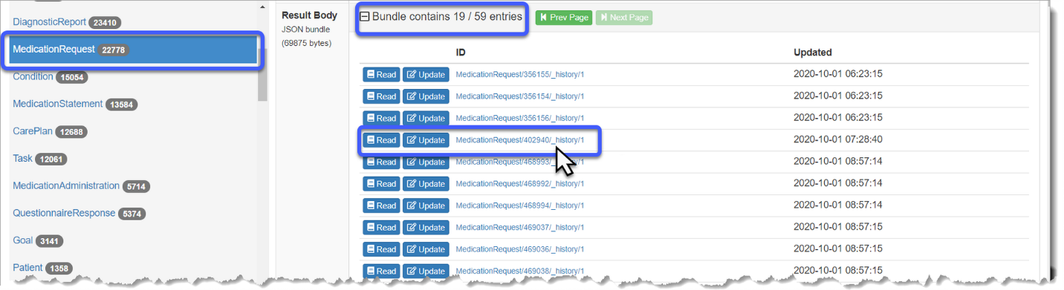

1. Below the Result Body is the **Raw Message** sectionwhich section contains the actual data from your query. The medication Resource will show you specific information related to a particular medicationReference e.g., code **Medication/3561**.

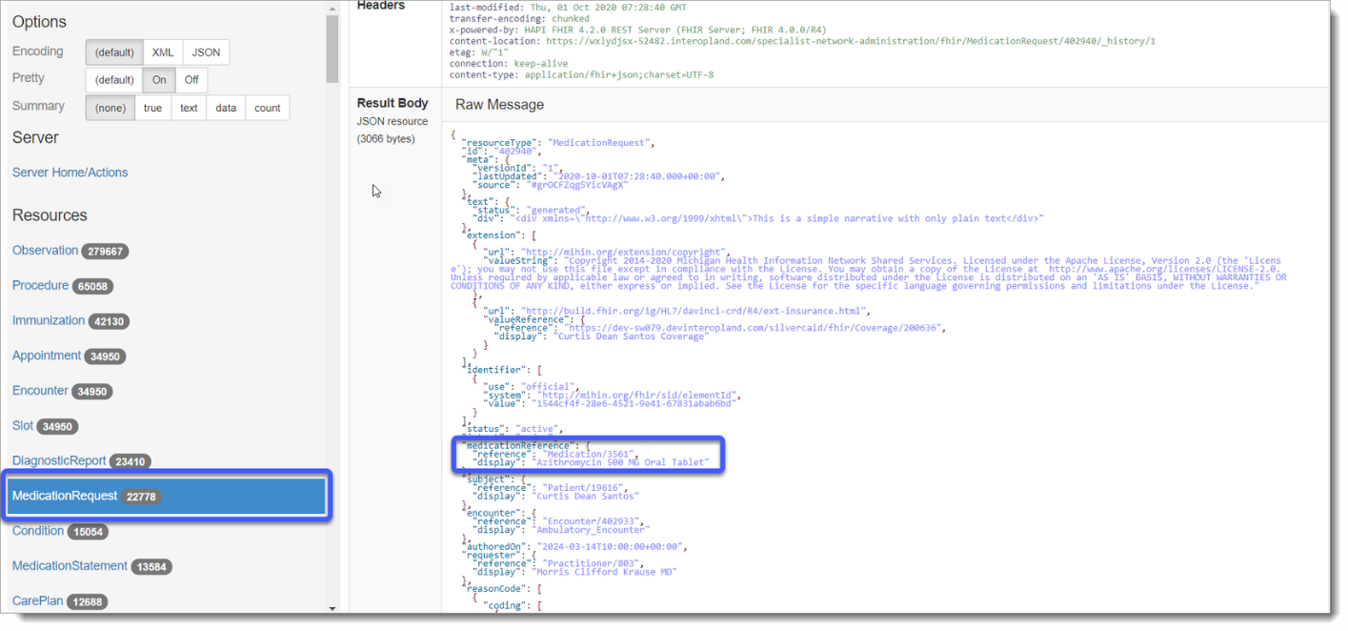

### Query 3: Find the rxnorm code Using the Medication Resource in the Specialist Network Administration PIT

1. Navigate to your **Resources** navigation menu then click **Medication**.
   1. Using your **Search Parameters** dropdown menu, choose **_id – The ID of the Resource**, verify your search limit is **Matches.**
   2. Then type the **Resource id** you found in the previous query **3561** in the corresponding box.
2. 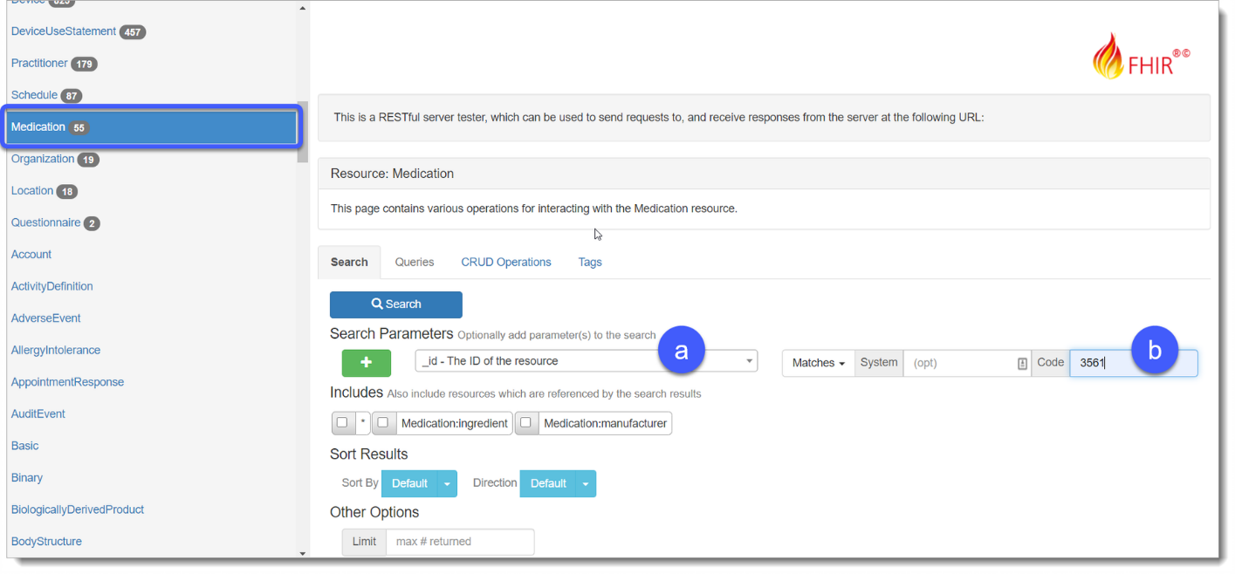Click **Search** () to display the list of Resources in the **Result Body**. There is only one Medication Resource for the Azithromycin.
3. Click **Read** to view the **Raw Message** information for the Resource.
   1. Scroll to the heading **system** with the URL <https://www.nlm.nih.gov/research/umls/rxnorm> to find Azithromycin rxnorm code number **248656**.

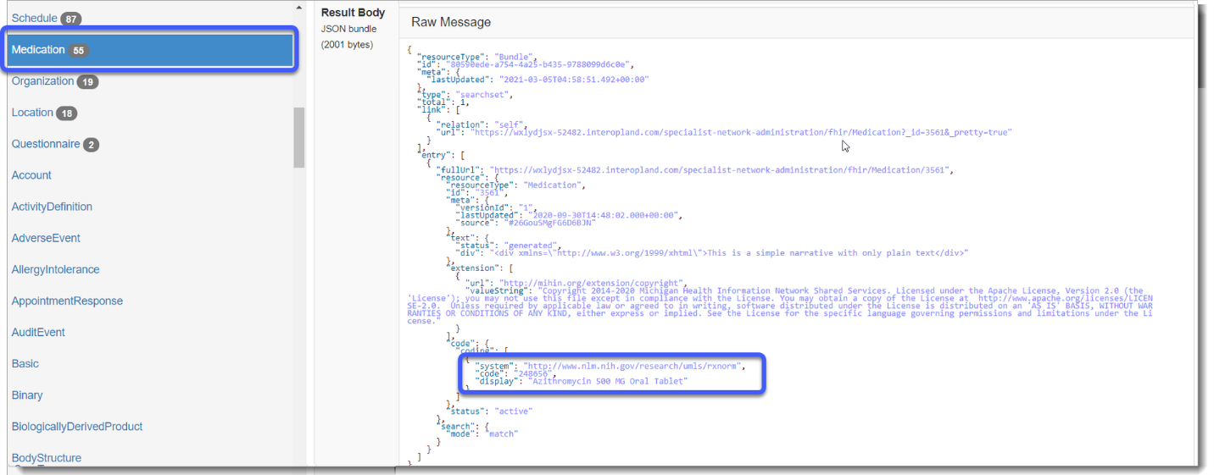***Tip:*** *Make a note of the rxnorm code number to use in a future query.*

### Query 4: Find the Patient id Using the Patient Resource in the Better Health Insurance Payer PIT.

1. Navigate to your **Search** tab in the **Better Health Insurance** PIT and choose **Patient** from the Resources navigation menu. Now use the **Search** **Parameters** tool find the patients insurance coverage
2. Using your **Search Parameters** arrow, choose **family – A portion of the family name of the patient**, verify your search is **Matches**, and then type the patient **family** name **Santos** in the corresponding box.
3. Click **Add** () to add a search parameter.
4. Then use your **Search Parameters** dropdown menu to choose **given – A portion of the given name of the patient**, verify your search limit is **Matches**, then type the patient **given** name e.g., **Curtis** in the corresponding box.
5. Click **Search** () to display the insurance records associated with **Curtis Santos**.

***Tip:*** *Records associated with a specific patient use a Patient id number in the PIT. A single patient can have records in multiple PITs. Each PIT uses its own numbering system. Solving problem statements for a patient using multiple PITs means tracking multiple patient ids.*

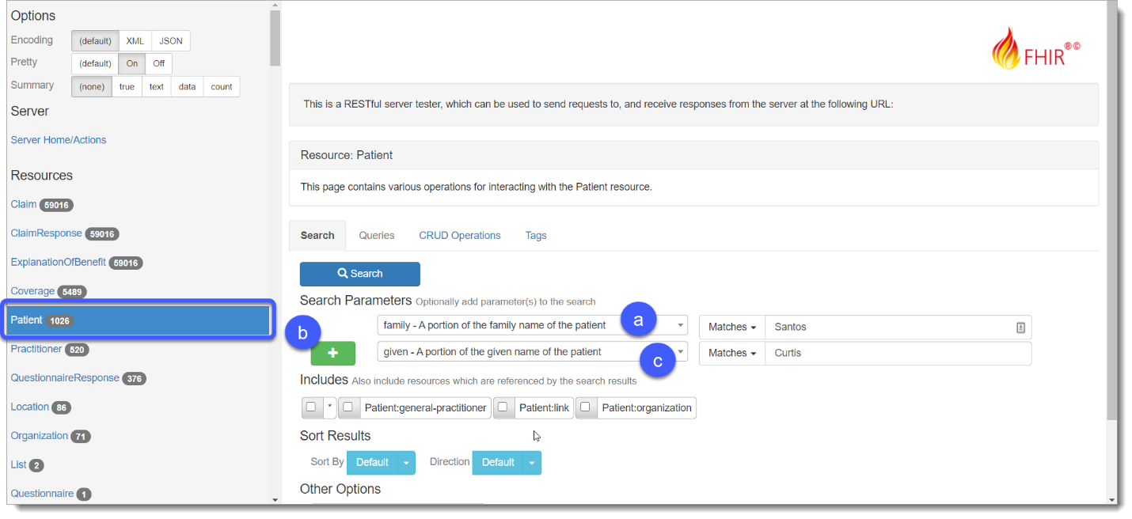

1. Scroll down or choose **Read** to view the record detail in the Raw Message.

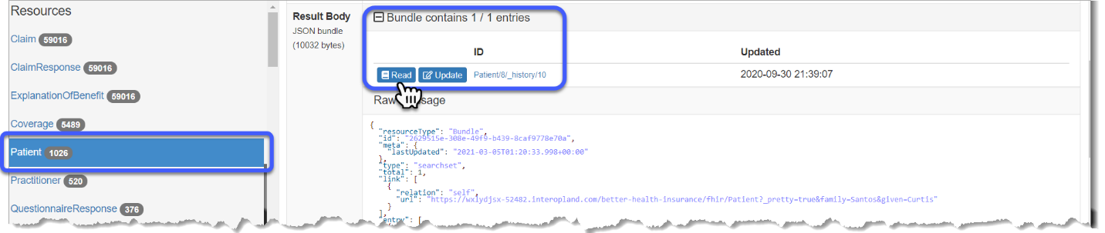*.*

1. Make a note of the **patient id** for Curtis **(8)** for future queries.

### Query 5: Find the Patient’s Current Coverage Plan Using the Coverage Resource in the Better Health Insurance Payer PIT

1. Now that you know the Patient Resource id for Curtis, you need to find his current coverage plan. To do this, use the left navigation menu and choose the **Coverage** Resource.
2. Click the **Search Parameters** arrow to choose **patient – Retrieve coverages for a patient.**
3. Type the **id** **(8)** for **Curtis Santos** in the corresponding search box.
4. Click **Search** () to display results.

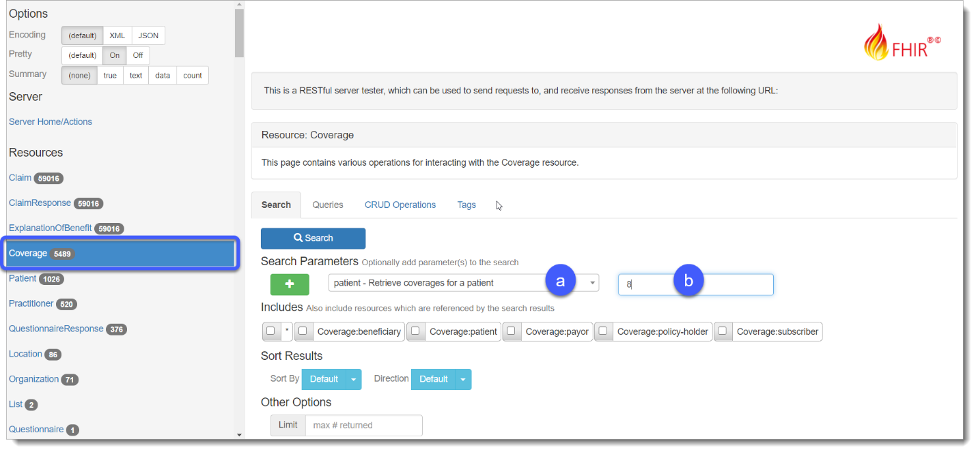

1. Multiple entries for Curtis display in the **Result Body**. Each Resource result represents a current or previous insurance plan with coverage information in the Raw Message.
   1. Click **Read** on Resource **45911** to view the Raw Message for Curtis’ current plan.

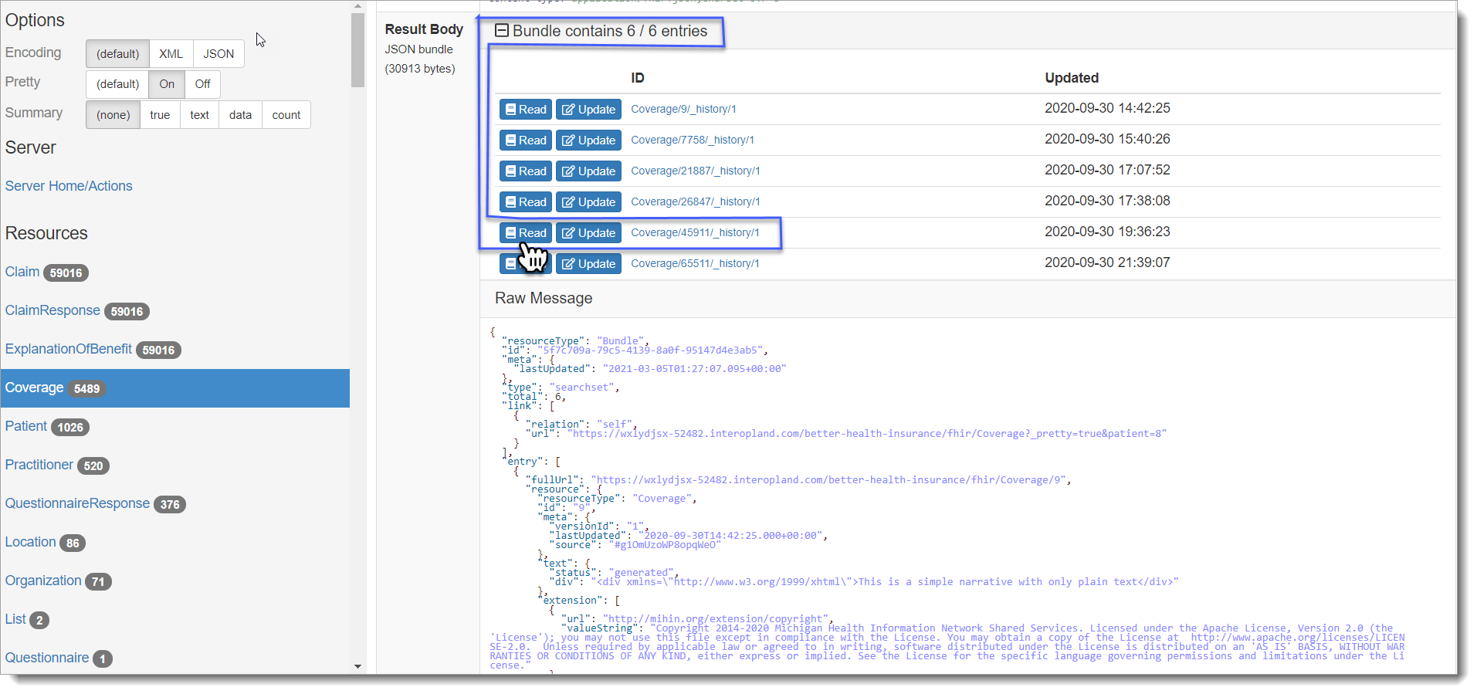

1. To find the current healthcare plan for Curtis, scroll down through the records and look at the coverage **period** which contains both the **start** and **end** dates for the plan.

***Tip:*** *Make a note of the coverage identifier* ***value****, 52cc9db6-49c3-4d72-813e-593c29908b32.*

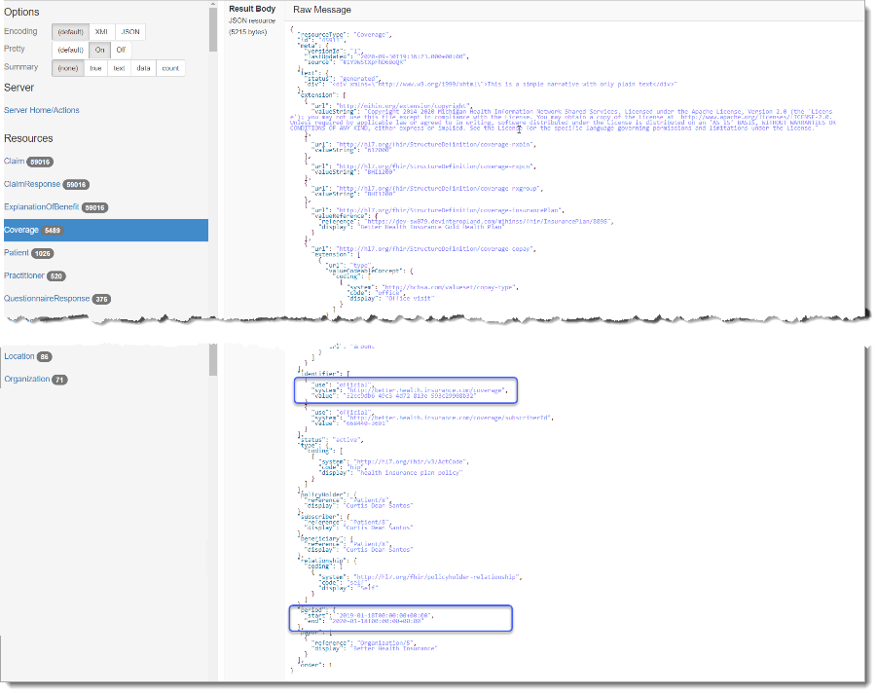

### Query 6: Find Formulary Coverage Plan id Using the InsurancePlan Resource in the MiHIN PIT

Now that you have the coverage identifier from the **Coverage** Resource, navigate to the IOL Sandbox Dashboard and open the **MiHIN** PIT.

1. Navigate to the Resource menu and select the **InsurancePlan** Resource.
   1. Use the Search Parameter **identifier – Any identifier for the organization (not the accreditat** with the limit set to **Matches**.
   2. Type the coverage identifier **code** for Better Health Insurance found in the previous query: **52cc9db6-49c3-4d72-813e-593c29908b32.**
2. 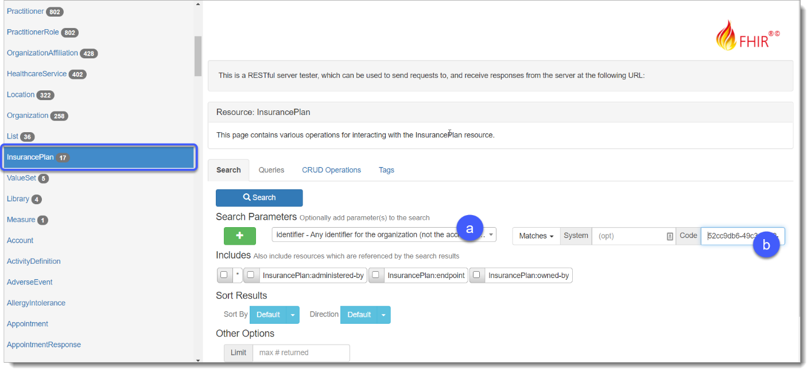Click **Search** ().
3. In the **Result Body**, one Resource is found related to the coverage identifier in your query.
   1. Click **Read** to see the **Raw Message** with detailed information on the insurance plan.
   2. Find the Better Health Insurance **coverageplan-id** with the value **12345XX9876543.**

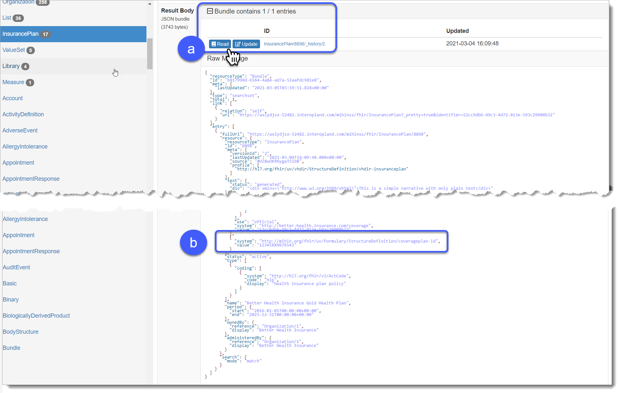***Tip:*** *Take note of the* ***coverageplan-id*** *to use in the next query.*

### Query 7: Determine the Drug’s Tier Using the Formulary Coverage Plan id and MedicationKnowledge Resource in the MiHIN PIT

1. Navigate to your **Search** tab in the **MiHIN** PIT and choose **MedicationKnowledge** from the Resources navigation menu.
   1. Using your **Search Parameters** dropdown menu, choose **code – Code that identifies this medication**, use the **Matches** search limit.
   2. Then type the code for **Azithromycin** **rxnom** in the corresponding box, **248656**.
2. 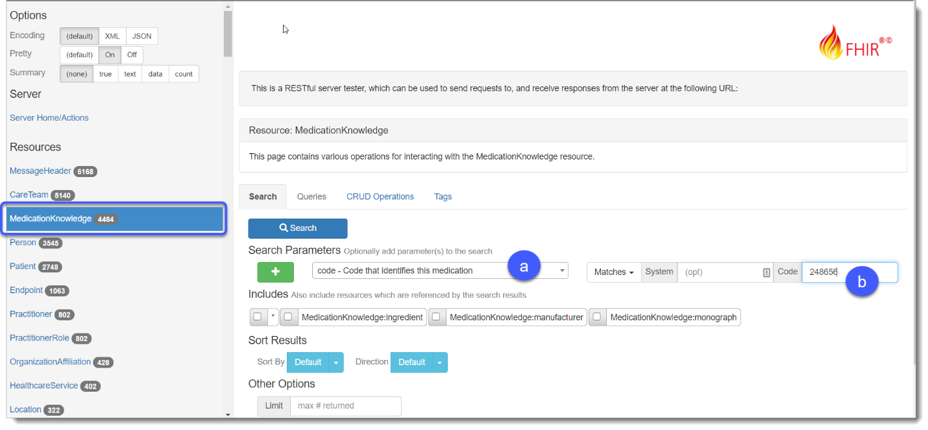Click **Search** ().
3. In the Result Body, there are two **MedicationKnowledge**Resource results for this drug as it relates to an insurance plan.
4. Click **Read** for Resource **26228** to see detailed information in the Raw Message.
5. Scroll to locate the formulary coverage plan **id** 12345XX9876543.
6. Make a note of the **MedicationKnowledge** Resource **id** **(26228)** to use in the next query.

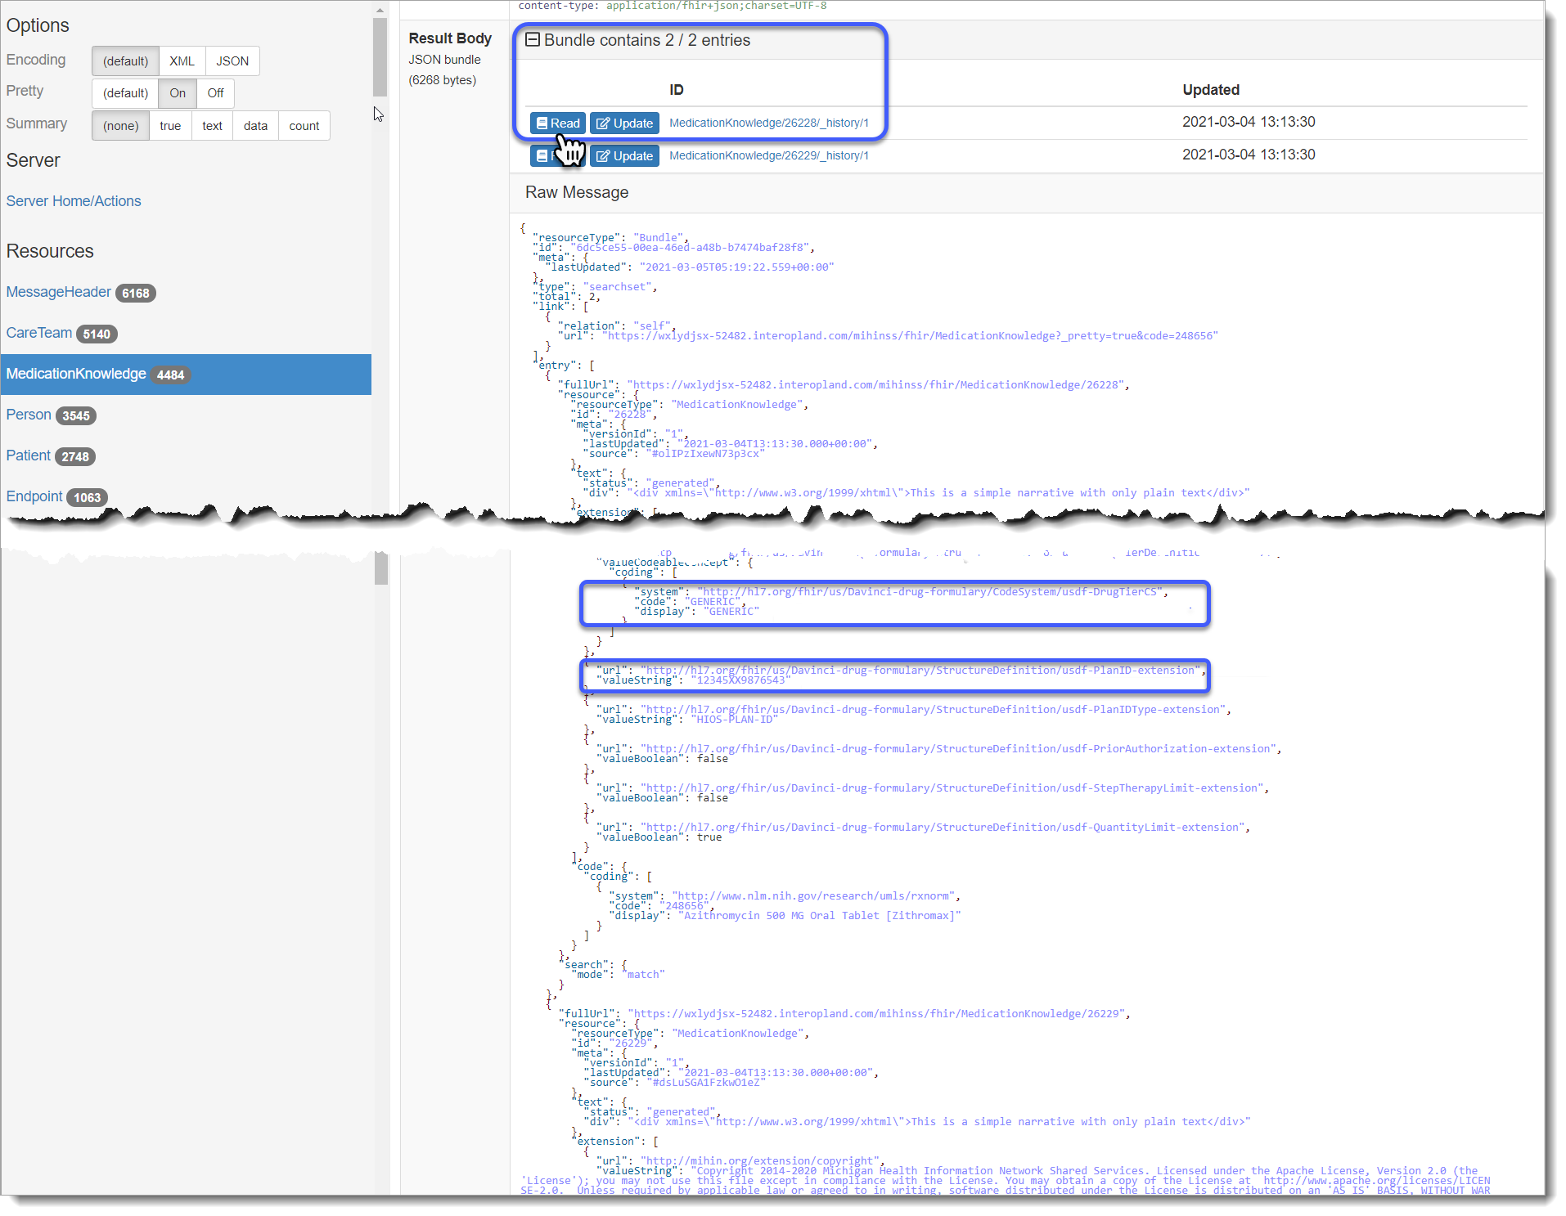For additional practice, review the other MedicationKnowledge Resources to see what drug formulary tier this medication belongs in as related to other insurance plans.

### Query 8: Find the Associated Copay for the Medication Tier Using the List Resource in the MiHIN PIT

Now that you know the tier for the prescribed medication, you can query the copay amount for medications of the **Generic** tier in the insurance plan for Curtis.

1. Navigate to your Resource menu and click the **List** Resource.
   1. Using the **Search Parameters** arrow, choose **item - Actual entry**.
   2. 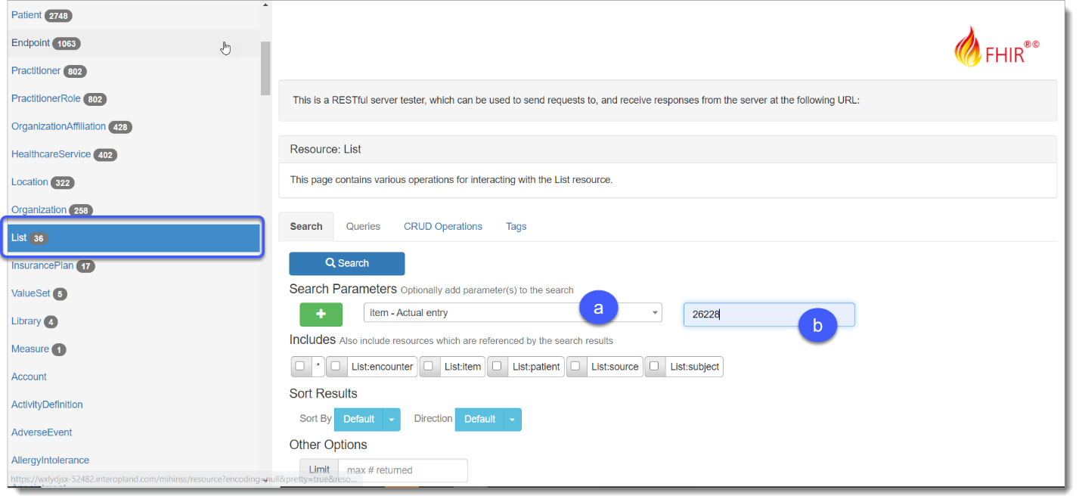Then type the MedicationKnowledge Resource **id** you found in the previous query e.g., **26228**.
2. Click **Search** ().
3. One result displays in the Result Body. Now you can scroll to locate:
   1. The **drugTierId**. For a **Generic** drug.
   2. The **copayAmount**. For this medication, you can see that Curtis will pay $20.00 for this prescription.

